

**Code Implementation For Category | Belayneh Mathewos**

**Category**

**Code on Progress:**

**Introduction**

All thing is going on but, there are some difficulties for me at this point of the coding stage. These difficulties may be discussed later. Even though this documentation shows where I am, what I am doing and I have faced.

**Code**

**PHP Code:**

**Connector Class**

To declare and asign a necessary terms to access a database and to create a connection to a database server.

Open the *loginAll2.php* file.

**PostItem Class**

Which retrives the database items name and displays it on webpage. It includes a connector class to create a connection to the database.

Open the *postItem.php* file.

**With CSS Code**

**Front Page(a sample home page) to test my code**

Styling a page with css, and navigation link to the display page is done.

Open the *frontPage.php* file.

**Sample database**

Look the exported file category2.

For furtherly look at the files in a zip file Category.

**Difficulties**

**FrontPage**

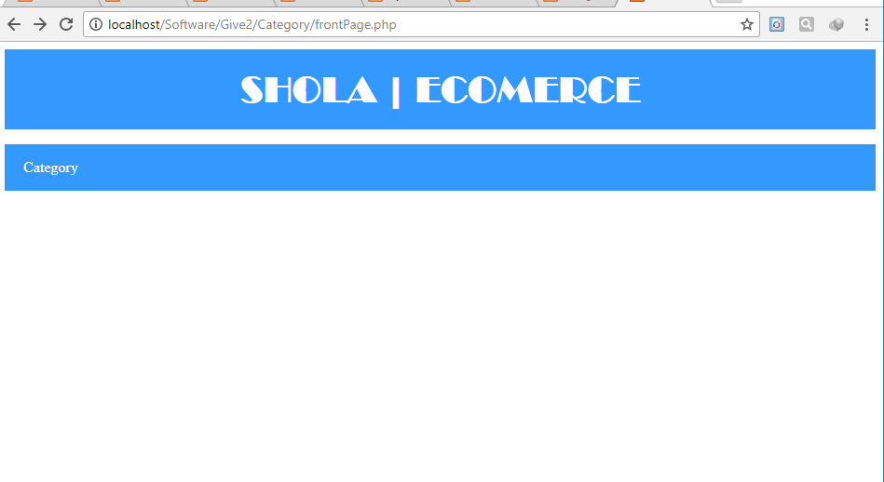

**PostItem**

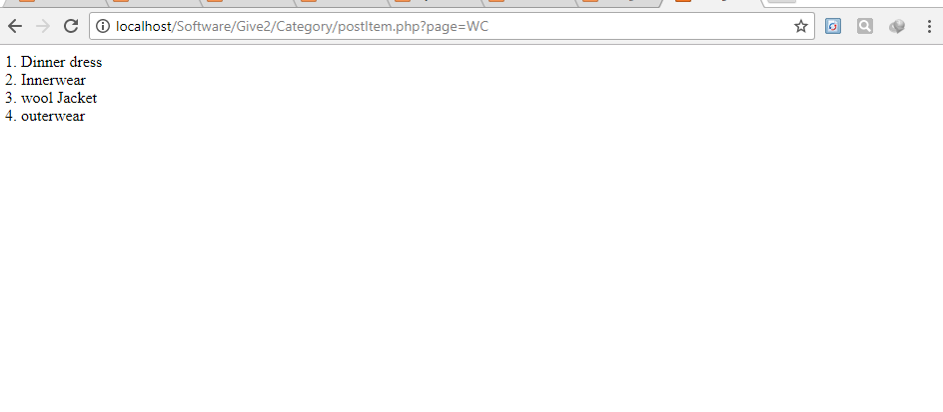

**Sample database**

